**BBC Master 128 – External Compact Flash Hard Drive Kit**

Thanks for buying this External Hard Drive from me. The BBC/IDE interface component of this kit is my own, new single chip custom programmable logic design, made to be compatible with various IDE patched operating systems for the BBC and Master Series Computers.

Connections on the interface are very straightforward:

* 1MHz BUS – This connects to the 34 way 1MHz bus connector underneath your Beeb. Ensure you do NOT connect it to the floppy drive, although no damage should result if you do, I say “SHOULD”, so best not to try!
* Power – Please use only the power supply included. If it gets damaged and you need to replace it, you’ll need one that supplies regulated +5v at at least 250mA with tip Positive, on a 2.1mm power jack.

The IDE interface is 8 bit, as opposed to 16 bit that you would find in an Arc, or your PC. We’re forced to using only 8 bit, because that is the width of the data bus in the Beeb, and what all the operating systems have been written for. There is a 16 bit interface available for the Beeb, but because there’s no support software for it, it still has the same limitations as this 8 bit one. Because of this, only half the capacity of the CF Card is available to the Beeb. A 1GB Card is used in this interface, giving 512MB of usable storage space.

**SOFTWARE**

ADFS 1.53 and HADFS 5.50, and their associated utilities have been supplied on ROM for the cost of the chip and disk for your convenience. They are also downloadable free of charge at J. G. Harstons website:

<http://www.mdfsnet.f9.co.uk/Info/Comp/BBC/IDE/>

Other resources, updates and utilities can be found there. If you have a specific problem with the operation of the ADFS, and especially with the Hard Drive Unit itself, please refer them to me directly. If the issue is with a technical operation on the HADFS, the utilities supplied on disk, or you notice a bug, contact me first if you prefer, or you may refer those back to the Author.

**GETTING STARTED**

Open up your Master case with the 4 screws under the casing, and put the lid to one side. Gently remove the plastic that contains the speaker and cartridge mount, and place it to one side, being careful not to pull the speaker cable out. If you do dislodge it, it is clearly marked where it should go back, but is under the keyboard, so a pain to get to.

The ROM supplied actually contains two sideways ROM images, one for the ADFS 1.53, and the other for the HADFS 5.50. Because of this, it can only be placed in either of 2 of the 3 sockets in the Master. I recommend using the lower socket as pictured, which is ROM banks 4 & 5 – this is because Elite requires Sideways RAM bank number 6, which would be taken up if you mounted the ROM on the top socket. Ensure the little “chip” at one end of the ROM faces in the same direction as all the other chips on the board – if you put it in the wrong way round, it will get destroyed. Make sure that all the pins are secured in the socket and that you haven’t accidentally bent one out of shape while inserting it.

Ensure the links near the ROM Sockets are set to the following configuration, as seen in the photo below:

LK19 – West (This selects banks 6 & 7 for RAM)  
LK18 – East  
LK12 – East (This selects banks 4 & 5 for ROM)

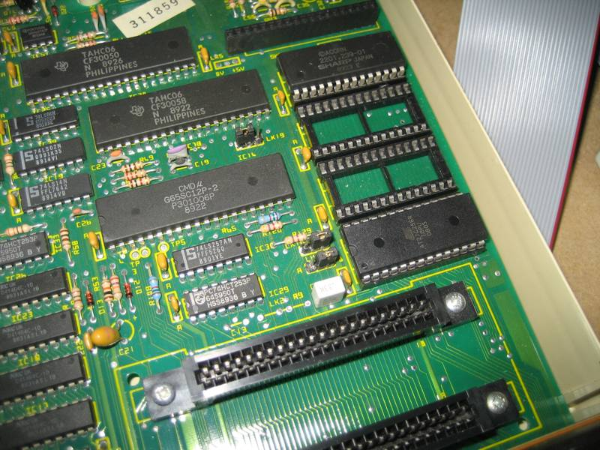

**RECONFIGURING THE SOFTWARE**

Once the new ROM is in place, first thing we need to do, is “unplug” the original ADFS 1.50 from the system. As this is part of the Master single chip MOS, we can’t physically do this, but we can do it in the configuration settings. Start by typing:

*UNPLUG 13

Now, we then tell the operating system to use ADFS 1.53 as our default filing system, and to use Hard Drives:

*CONFIGURE FILE 4  
*CONFIGURE HARD

ROM Image number 4 is the Acorn ADFS 1.53 (providing you followed my advice and fitted the ROM in the indicated socket). The HADFS is also available on the chip, and is at location 5, should you prefer to use that filing system. But for now, we need to remove the HADFS from the system, as the Drive supplied is not formatted for it:

*UNPLUG 5

Once you’ve done that, turn the Beeb off and connect the External drive unit, plug it into its power supply, and connect it to the mains. The Green LED should illuminate on the front of the drive.

Power the Beeb back on, and you should get the Acorn ADFS message, with the Basic prompt. Typing:

*CAT

Should give you the Drive directory, and you’re ready to go!

**FORMATTING A NEW CARD**

If you wish to use a different CF card in the interface, open the case, remove the old card carefully and insert a new one. Turn the Beeb on, and after a very brief delay, you should get the BASIC message and prompt. If not, recheck the CF card and connections have not come dislodged. Do a <CTRL><BREAK> while watching the “ACT” light, it should flash as the reset is performed.

At this point, if you are using a fresh Compact Flash card, and you type:

*CAT

You should get the message “Broken Directory”. Place the supplied utilities disk in your floppy Drive 0 (which now you have a hard drive, has moved to Drive 4 under the ADFS – it’s unaffected under regular 1770 DFS) and type:

*MOUNT 4  
CHAIN “$.UTILS.HDINIT”

After a brief delay, the HDInit screen should come up. HDInit is part of the HADFS suite of software, but it serves our purpose well with ADFS 1.53. You may want to read up on the program using the manual supplied on the utilities disk, but I’ll give you a brief overview of formatting a new card here.

At the top, will be the drive selected as “Current Drive”. This will probably default to Drive 4, we want to use Drive 0. So press “D” to select drive, then type “0”. Check that at the top, the drive is now “Current Drive 0 (IDE Device 0)”.

Press “I” to investigate the drive. Because of a quirk in the way CF Cards report the info (16 bit rather than 8 bit), the info might look a bit messed up, with silly capacity figures, but the basics are there, we just need to correct it. In the “Total Sectors” field, you will see the size, for example using a 1GB CF card, as &FF1EFF00. This is “almost” right, we just need to tell HDInit the correct figure, which is the same, but knocking off the front two FFs. So press “Z” to set the size, and type whatever the size is, but leave the two front FFs off, so in our example, we would enter “&1EFF00”. Make sure you use the correct figures for the card you are using – get it wrong, and the card could work for now, but corrupt as it fills up. You should now notice that the capacities have corrected themselves, and the available 8 bit size is something like 495.9M, or half of whatever your card is, up to 512MB.

Now, we simply press “F” to Format the drive. Type “NO” when it asks you to leave space for the HADFS system, and “YES” to confirm formatting. Once done, the program resets, and you can then do a <CTRL><BREAK>, to reset the computer.

Now Type:

*CAT

And you should get a blank directory. Typing:

*FREE

Should confirm the free space you have available. Check this carefully, if HDInit has somehow failed to write the correct values here, it will need to be rerun, but once you start loading software, it can’t be changed, so best to check it before starting.

That should be all you need to get started. If you need any further assistance, please don’t hesitate to contact me. I’m here to help if I can! If you do encounter problems that seem frustrating – don’t dive in and reach for the Negative Feedback button, once you leave that, I’ll no longer want to play any part and consider the matter closed. I’ve had this system working on many machines, using many different cards – some can play up and cause trouble, others work just smooth, but I have always managed to get everything working eventually! The software has it’s quirks, but is usable, and is under constant improvement. Remember we are hobbyists, not commercial retailers!

Thanks once again for purchasing this item from me.

