**BBC Model B & BBC Master 128 – External Dual Removable Compact Flash Hard Drive Kit**

Thanks for buying this External Hard Drive from me. The BBC/IDE interface component of this kit is my own, new single chip custom programmable logic design, made to be compatible with various IDE patched operating systems for the BBC and Master Series Computers. ***Even if you choose not to read these instructions, I urge you to please read the section on swapping cards.***

Connections on the interface are very straightforward:

* 1MHz BUS – This connects to the 34 way 1MHz bus connector underneath your Beeb. Ensure you do NOT connect it to the floppy drive, although no damage should result if you do, I say “SHOULD”, so best not to try!
* Power – Please use only the power supply included. If it gets damaged and you need to replace it, you’ll need one that supplies regulated +5v at at least 250mA with tip Positive, on a 2.1mm power jack. I can supply a replacement if you have difficulty obtaining one.

***DO NOT USE AN UNREGULATED POWER SUPPLY – YOU WILL BLOW THE INTERFACE UP!***

The IDE interface is 8 bit, as opposed to 16 bit that you would find in an Arc, or your PC. We’re forced to using only 8 bit, because that is the width of the data bus in the Beeb, and what all the operating systems have been written for. There is a 16 bit interface available for the Beeb, but because there’s no support software for it, it still has the same limitations as this 8 bit one. Because of this, only half the capacity of the CF Card is available to the Beeb. Up to 2 x 2GB Cards can be used in this interface, giving 2GB of usable storage space, across 4 partitions.

**SOFTWARE**

ADFS 1.53 (For the BBC Master 128) and ADFS 1.33 (For the BBC Model B) are supplied on a single 27c256 ROM chip, and a selection of utilities have been supplied on disk for your convenience.

There is also a CD containing a multitude of software, utilities, images, manuals etc. Please take a look on the CD and have a browse to some of the readme files for more information. I would suggest that you use ADFS Explorer on the PC for creating Hard Drive images for loading onto the CF cards via the CFRESTORE program..

**GETTING STARTED – BBC Model B**

Open the case of the Beeb by removing the 2 screws at the rear, and 2 screws at the back. You will also need to remove the keyboard to gain access to the ROM sockets. The Beeb has 4 ROM slots available, and their priority is from right to left. If you wish the ADFS to boot up first, make sure the supplied ROM is in a higher priority socket – IE more to the right – than your DFS ROM. Ensure the little “chip” at one end of the ROM faces in the same direction as all the other chips on the board – if you put it in the wrong way round, it will get destroyed. Make sure that all the pins are secured in the socket and that you haven’t accidentally bent one out of shape while inserting it. The BBC ROM sockets can only read the top half of a 27c256 ROM, so only the ADFS 1.33 is available for use, even though ADFS 1.53 is also contained in the ROM.

Refit the keyboard, but keep the lid off until you’re happy that the ROM is installed correctly and everything checks out. You can skip the next section on configuration as it doesn’t apply to the BBC Model B.

**GETTING STARTED – BBC Master 128**

Open the Masters case with the 4 screws under the casing, and put the lid to one side. Gently remove the plastic that contains the speaker and cartridge mount, and place it to one side, being careful not to pull the speaker cable out. If you do dislodge it, it is clearly marked where it should go back, but is under the keyboard, so a pain to get to.

The ROM supplied actually contains two sideways ROM images, one for the ADFS 1.53, and the other for the ADFS 1.33. Because of this, it can only be placed in either of 2 of the 3 sockets in the Master. I recommend using the lower socket as pictured, which is ROM banks 4 & 5 – this is because Elite requires Sideways RAM bank number 6, which would be taken up if you mounted the ROM on the top socket. Ensure the little “chip” at one end of the ROM faces in the same direction as all the other chips on the board – if you put it in the wrong way round, it will get destroyed. Make sure that all the pins are secured in the socket and that you haven’t accidentally bent one out of shape while inserting it.

Ensure the links near the ROM Sockets are set to the following configuration, as seen in the photo below:

LK19 – West (This selects banks 6 & 7 for RAM)  
LK18 – East  
LK12 – East (This selects banks 4 & 5 for ROM)

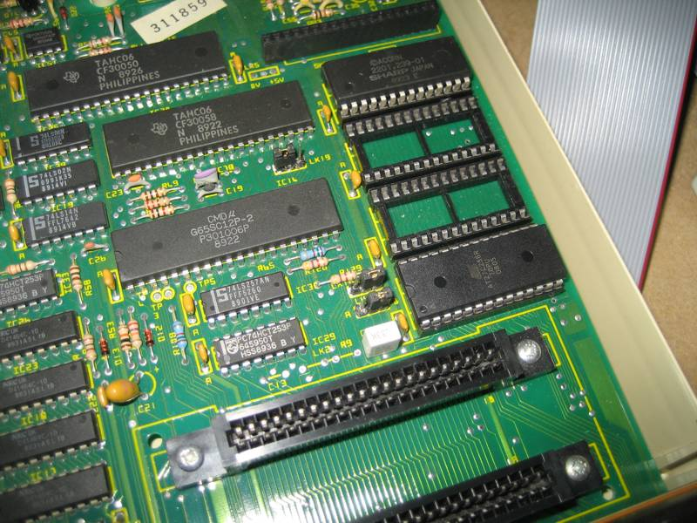

**RECONFIGURING THE SOFTWARE – BBC Master 128 only**

Once the new ROM is in place, first thing we need to do, is “unplug” the original ADFS 1.50 from the system. As this is part of the Master single chip MOS, we can’t physically do this, but we can do it in the configuration settings. Start by typing:

*UNPLUG 13

Now, we then tell the operating system to use ADFS 1.53 as our default filing system, and to use Hard Drives:

*CONFIGURE FILE 4  
*CONFIGURE HARD

ROM Image number 4 is the Acorn ADFS 1.53 (providing you followed my advice and fitted the ROM in the indicated socket). The ADFS 1.33 is also available on the chip, and is at location 5, and for the BBC Master 128, we must also disable this from the system as follows:

*UNPLUG 5

Once you’ve done that, turn the Beeb off and connect the External drive unit to the 1MHz bus port. ***DO NOT connect it to the Floppy Drive port!*** Insert a Compact Flash card into the top slot, marked 0/1. Take care when inserting cards, do not use excessive force or you may bend the pins in the receptacle, and they are easily damaged. Plug the unit it into its power supply, and connect it to the mains. The Orange LED should illuminate on the front of the drive.

Power the Beeb back on, and you should get the Acorn ADFS message, with the Basic prompt. Typing:

*CAT

If you’re using a blank CF card, you should get the message “Broken Directory”. If the card has ADFS data on it, you should see the catalogue. If you power the Beeb on without a CF card in the drive, or only a CF in slot 2/3, then the Beeb may hang at the ADFS message.

**SWAPPING CARDS – THIS IS IMPORTANT – PLEASE READ CAREFULLY OR YOU WILL CORRUPT YOUR CF CARD**

In order to swap cards on the interface, it’s simply a matter of plugging one out, and plugging the other one in. The unit is semi-hot swappable – this means that you may leave the Beeb turned on, but in order to change card correctly, you must follow this simple procedure.

1. Ensure the Beeb has finished writing data to the card, and the Blue activity light is out.
2. Unplug the card you wish to change, and re-insert a replacement.
3. *MOUNT X, where X is the name of the drive you wish to access.

***You must always use *MOUNT when you have changed a CF card while the Beeb has been left on***. This is **VITALLY** important. If you do not do this, and attempt to save a program to a changed card, you **WILL** corrupt the cards directory, as the Beeb will think is still has the old card in the slot. This is not necessary if you have turned the Beeb off during this process, as it will reinitialise when it is next turned on. With some cards, you may need to power the interface off when changing cards, otherwise the CF card will not initialise and the Beeb will hang when it tries to read it.

Please read the above paragraph again, so you’re 100% clear on its meaning.

**FORMATTING A NEW CARD**

So you have a new card is in place? Time to format the card.

Place the supplied utilities disk in your floppy Drive 0 and type:

*DISC  
LOAD “HDINIT”  
*FADFS  
RUN

After a brief delay, the HDInit screen should come up. HDInit is part of the HADFS suite of software, but it serves our purpose well with the CF system and ADFS. You may want to read up on the program using the manual available on the Authors website, but I will give a brief overview of formatting a card here.

At the top, will be the drive selected as “Current Drive”. This may default to Drive 4, we want to use Drive 0. So if it is set to 4, press “D” to select drive, then type “0”. Check that at the top, the drive is now “Current Drive 0 (IDE Device 0)”.

Take a look at the “Device Width” setting. It usually defaults to 16 bit. As this interface is 8 bit, we need to set this by pressing the <TAB> key.

Now press “I” to investigate the drive. Check that the indicated capacity of drive 0 looks about right, it should be just under half of the total capacity of the CF card, for example, if the card is 1GB, that is 1024MB, it should report around 495MB.

Now, we simply press “F” to Format the drive. Type “NO” when it asks you to leave space for the HADFS system, and “YES” to confirm formatting. Once done, the program resets, and you can then do a <CTRL><BREAK>, to reset the computer.

Now Type:

*CAT

And you should get a blank directory. Typing:

*FREE

Should confirm the free space you have available. Check this carefully, if HDInit has somehow failed to write the correct values here, it will need to be rerun, but once you start loading software, it can’t be changed, so best to check it before starting.

If you have a 2GB CF Card, you can format a second partition as Drive 1, by going back to HDINIT and selection drive 1 instead of 0, using the procedure above. Once you’ve done that, check the second partition by typing:

*MOUNT 1

And then

*CAT

And

*FREE

To check the second partition on the card is formatted correctly. The size of the second partition may be very slightly smaller than the first, this is normal, and is due to slight differences in actual formatted cards between manufacturers.

**THINGS TO NOTE WHEN USING 2 CARDS**

I’ve tested this system with a range of different sizes and makes of CF card, but obviously I can’t check every single one ever made. The interface “should” work just fine with most cards that you use, and should be happy even with different manufacturer and different speeds of cards in the two slots. However, if you do experience issues, try using two of the same type and size of cards in both the slots. The slots are configured to run at 3.3v only, as I have found 5v causes problems when running two cards together. All new cards on the market now should be compatible with the 3.3v system, please check with your card manufacturer if you are unsure. Some makes of card, even when using 2 of the same, can be “problematic” in initialisation, in that you may need to repower the interface, the Beeb, or both before the cards will mount correctly.

If you prefer, I can supply 1GB cards that I have extensively tested with this system and found to run 100%. They are made by Integral, and use Toshiba OEM 3.3v cards. I’ve found Fuji and Sandisk to work perfectly as well.

I recommend that if you are only using 1 card, that you use it in slot 0/1. On the IDE bus, the top slot is the Master, and the lower slot the Slave. It is possible to use a single card in slot 2/3, but apart from it being pointless, you will have to boot the Beeb in FADFS mode (<CTRL><F><BREAK>) so that it does not mount a drive, then manually type:

*MOUNT 2

(or 3) to get the CF directory mounted. The CF may not respond at all in this instance, as there is effectively no Master drive on the IDE bus, only a slave, and some CF cards may get confused by this.

That should be all you need to get started. If you need any further assistance, please don’t hesitate to contact me. I’m here to help if I can! If you do encounter problems that seem frustrating – don’t dive in and reach for the Negative Feedback button, once you leave that, I’ll no longer want to play any part and consider the matter closed. I’ve had this system working on many machines, using many different cards – some can play up and cause trouble, others work just smooth, but I have always managed to get everything working eventually! The software has it’s quirks, but is usable, and is under constant improvement. Remember we are hobbyists, not commercial retailers!

Thanks once again for purchasing this item from me.

