**KIT/IDE1MHZ - BBC Model B & BBC Master 128 – Internal Compact Flash Interface Kit**

Thanks for buying this IDE Interface kit from me at RetroClinic. The BBC/IDE interface component of this kit is my own, new single chip custom programmable logic design, made to be compatible with various IDE patched operating systems for the BBC and Master Series Computers.

Connections on the interface are very straightforward:

* 1MHz BUS – This connects to the 34 way 1MHz bus connector underneath your Beeb. Ensure you do NOT connect it to the floppy drive, although no damage should result if you do, I say “SHOULD”, so best not to try!
* Compact Flash socket – where the CF card plugs in!
* PWR – ***USE THE POWER CONNECTOR ON THE IDE INTERFACE, NOT THE ONE NEAR THE CF CARD!*** This is pin compatible with the standard 3.5” floppy drive power connector, in that pin 1 is +12v (unused), pins 2-3 are 0v (GND, Black cable), and Pin 4 is +5v (Red cable). There is no power supplied through the1MHz bus, so this connection is needed.

There is one jumper on the IDE interface – JP1, which when connected, supplies 5v through pin 20 of the interface to power CF adaptors that can use this facility. The CF adaptor supplied uses this, so leave this jumper on. The ACT light shows when the drive is in use. If you intend to mount this interface in an enclosure, you can desolder the ACT LED, and put a header there to bring the LED to the outside of the case. It is current limited through a 1k resistor, so no extra one is needed.

The IDE interface is 8 bit, as opposed to 16 bit that you would find in an Arc, or your PC. We’re forced to using only 8 bit, because that is the width of the data bus in the Beeb, and what all the operating systems have been written for. There is a 16 bit interface available for the Beeb, but because there’s no support software for it, it still has the same limitations as this 8 bit one. However, 1GB CF Cards are not at all expensive nowadays, and they will format to the full 512MB that ADFS (and many other computers of that era) can handle, so giving you plenty of space to work with. I’ve tested the interface with many cards, and all the ones I’ve tried seem to work just fine, but I can’t warrant that every single card will work perfectly. Some cards are 5v only, some 3.3v only, and some can use both. I have set the power jumper on the CF Interface card – JP2 – to 3.3v, as most cards seem happy at this. If you encounter errors, try putting it to 5v. If this does not work either, then the card may not be compatible, please contact me in this instance to see if I can shed light on the matter.

**SOFTWARE**

A ROM is supplied in the kit which contains two Different versions of Acorn ADFS. One is ADFS 1.53 for the BBC Master, and the other is ADFS 1.33 for the BBC B.

A Floppy disk of various utilities have also been supplied on DFS disk. Some of these are part of the HADFS suite, a freeware operating system by J.G. Harston, whist others have been purposely written for this application. Use of some of these will be described later in this document, but the main one is “HDINIT”, which is the program that enables you to format CF cards on the interface.

**INSTALLATION**

Two sets of installation instructions follow, one for the BBC Master, and one for the BBC Model B. At the time of writing, the kit has been tested with the BBC Model B+ 64K and 128K, and has found to operate perfectly with the supplied software. I have not as yet written separate instructions for these models, but they are almost identical to that of the Model B, except for the placement of the ROM. Please look in your B+ reference manual if you need to consult about fitting ROMS to that model, or feel free to contact me for support or updated instructions.

**INSTALLATION ON A BBC MASTER 128 - GETTING STARTED**

Open up your Master case with the 4 screws under the casing, and put the lid to one side. Gently remove the plastic that contains the speaker and cartridge mount, and place it to one side, being careful not to pull the speaker cable out. If you do dislodge it, it is clearly marked where it should go back, but is under the keyboard, so a pain to get to.

As mentioned above, the ROM supplied contains two sideways ROM images, one for the ADFS 1.53, and the other for ADFS 1.33. Because of this, it can only be placed in either of 2 of the 3 sockets in the Master. I recommend using the lower socket as pictured, which is ROM banks 4 & 5 – this is because Elite requires Sideways RAM bank number 6, which would be taken up if you mounted the ROM on the top socket. Ensure the little “chip” at one end of the ROM faces in the same direction as all the other chips on the board – if you put it in the wrong way round, it will get destroyed. Make sure that all the pins are secured in the socket and that you haven’t accidentally bent one out of shape while inserting it.

Ensure the links near the ROM Sockets are set to the following configuration, as seen in the photo below:

LK19 – West (This selects banks 6 & 7 for Sideways RAM)  
LK18 – East (This selects banks 4 & 5 for the ROM socket)  
LK12 – Unchanged - this is a configuration for the cartridge slot, and is not used in the CF application, so keep it as it was.

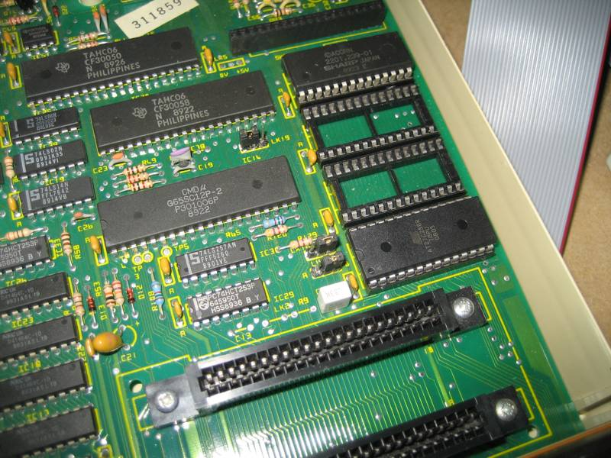

For the Interface, you may wish to route the 1MHz bus cable under the motherboard, or on top for convenience. Either way, you will probably have to remove some plastic of the casing below the socket near the 1MHz bus connector, to route the cable through. If you do route it under the motherboard, it will need to be removed for access.

Next, you need to fit the power cable. Referring to the photo below, unplug the two power connectors to the motherboard at locations PL19 and PL20. Connect the male spade connectors to the power supply wires, ensuring that Red connects with Red, and Black connects with Black. Then, plug the 2 remaining female connectors from the supplied lead, Red into PL19, and Black into PL20. The 2 way terminal block supplied is not used for the Master installation.

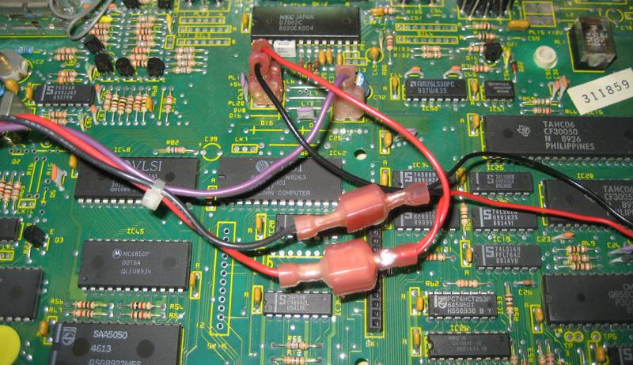

Double check that you have the polarities correct, IE Red to Red, Black to Black. If you get them the wrong way round and turn the computer on, you may blow it all up!

You can now mount the Interface PCB in a suitable location. You may wish to mount it on the main PCB, but make sure you don’t attach the sticky pads to a chip that likes to get hot. Best place I think for it is upside down on the case, as shown in the photo below.

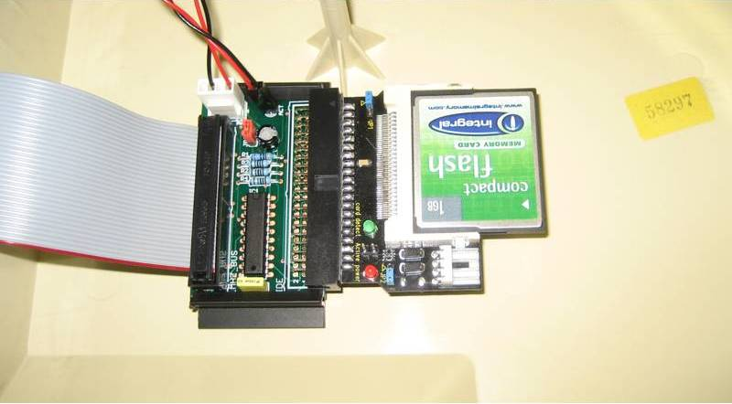

Once you have connected the 1MHz bus cable, fitted the ROM and connected the power cable, you can power up the machine, but first do so without a CF card plugged in. Make sure the power red LED comes on on the CF adaptor card. If so, turn off, then insert your CF card, and turn the power back on. Check now the green Card Detect light is also on.

Once you have the Power LED and the Card Detect light, it’s time to reconfigure the machine to use the new ADFS. If one or both are not lighting up, check the connections, reset everything, including detaching the CF card interface from the IDE PCB, and reseat the JP1 jumper. Contact me if you still get no joy at this stage.

**RECONFIGURING THE SOFTWARE – BBC MASTER 128**

First thing we need to do, is “unplug” the original ADFS 1.50 from the system (or 2.03 if using MOS 3.50). As this is part of the Master single chip MOS, we can’t physically do this, but we can do it in the configuration settings. Start by typing:

*UNPLUG 13

Now, we then tell the operating system to use ADFS 1.53 as our default filing system, and enable the Hard Drive:

*CONFIGURE FILE 4  
*CONFIGURE HARD

ROM Image number 4 is the Acorn ADFS 1.53 (providing you followed my advice and fitted the ROM in the indicated socket). ADFS 1.33 is also available on the chip, and is at location 5, but as that is meant for the BBC Model B, we need to disable it, so type:

*UNPLUG 5

Once you’ve done that, do a <CTRL><BREAK>, and the machine should reboot with Acorn ADFS, and after a very brief delay, you should get the BASIC message and prompt. If not, recheck the CF card and connections have not come dislodged. Do a <CTRL><BREAK> while watching the “ACT” light, it should flash as the reset is performed.

At this point, if you are using a fresh Compact Flash card, and you type:

*CAT

You should get the message “Broken Directory”. If you have a pre-formatted card supplied, then the directory should come up, and you can start to play! If you have purchased a new blank card yourself, you can now skip to the section on Formatting a Card, which is the same procedure for both the BBC Model B and Master 128.

**INSTALLATION ON A BBC MODEL B - GETTING STARTED**

If you have Sideways RAM, and wish to run the ADFS from there to maximise available memory, you can ignore this section on fitting the EPROM, and just proceed to fit the interface.

Open up your BBC case with the 2 screws under the casing and 2 at the rear, and put the lid to one side. You will need to remove the keyboard which is held on by two nuts and bolts either side. Remember where the speaker wire plugged in to! That will reveal the 5 ROM sockets in the lower right hand corner of the machine.

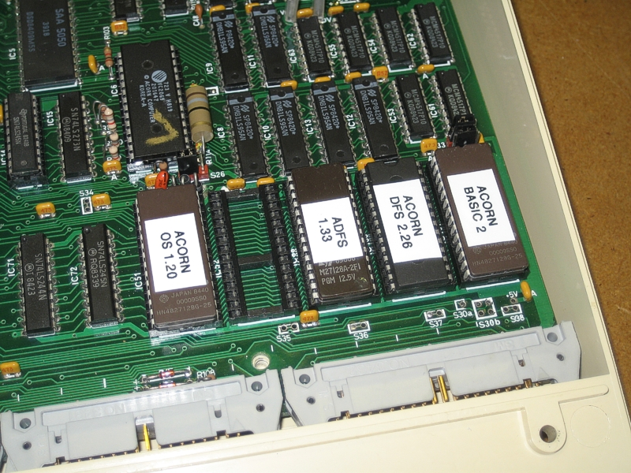

My recommendation for the placement of the ROMs is as shown in the above photo. Your ROMs may look slightly different, or be marked up in a different way, for example Acorn OS 1.20 may have the letters PB04 written on it somewhere, and Acorn Basic 2 may have PB05. The OS 1.20 mustn’t move from its position on the left, but the other ROMs can be placed in order of priority.

The ROM on the right will boot first, followed by the 2nd from the right and so on, so in this case, BASIC will start up first, followed, by the DFS then the ADFS. This means that when you turn your machine on, it will default to the Disk Filing System. If you prefer to have the hard drive initialise every time you turn on the machine, swap these two around, or make sure that the ADFS is in a higher priority (IE more to the right) socket than any other filing system. If using a ROM/RAM expansion board, please refer to the instructions of that board for the order or priority of sockets.

When fitting any ROMs, always ensure the little “chip” at one end of the ROM faces in the same direction as all the other chips on the board – if you put it in the wrong way round and power the Beeb up, it will get destroyed. Make sure that all the pins are secure in the socket and that you haven’t accidentally bent one out of shape while inserting it.

**FITTING THE INTERFACE**

For the Interface, you may wish to route the 1MHz bus cable under the motherboard, or on top for convenience. If you do route it underneath for neatness, you will need to remove the PCB and may have to shave some plastic off of the lower casing where the 1MHz bus connector pokes out.

Next, you need to fit the power cable. The cable supplied is plug and play for a Master, but unfortunately not for a BBC B. You will need to cut the cable at the end with the red Faston connectors, so all 4 connectors are removed, leave as much cable as possible with the white connector at the other end. Using the 2 way terminal block, strip the wires back 5mm and attach one end to the red and black of the power cable with a small screwdriver. There are 3 sets of red and black cables going to various places on the main board. Choose one pair, and splice the supplied power cable into them using the terminal block. Soldering is a better way to connect the cables, if you have an iron. Either way, make sure you connect Red to Red and Black to Black. Things will blow up if you get them backwards!

You can now mount the Interface PCB in a suitable location. You may wish to mount it on the main PCB, but make sure you don’t attach the sticky pads to a chip that likes to get hot. Best place I think for it is upside down on the case, as shown in the photo below.

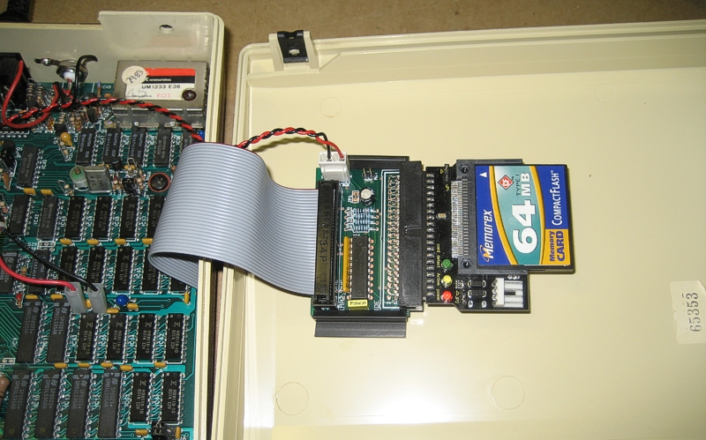

Once you have connected the 1MHz bus cable, fitted the ROM and connected the power cable, you can power up the machine, but first do so without a CF card plugged in. Make sure the power red LED comes on on the CF adaptor card. If so, turn off, then insert your CF card, and turn the power back on. Check now the green Card Detect light is also on.

Once you have the Power LED and the Card Detect light, you’re good to proceed to the next stage. If one or both are not lighting up, check the connections, reset everything, including detaching the CF card interface from the IDE PCB, and reseat the JP1 jumper. Contact me if you still get no joy at this stage.

**INITIAL TESTING OF THE INSTALLATION**

There is no configuration to set on the BBC as there is on the Master, so if you’ve got everything connected correctly, then it should work on the first attempt. Due to the way the ROM sockets are configured on a BBC Model B, the ADFS 1.53 is not accessible, and only ADFS 1.33 will appear in the ROM list.

If you have switched on your machine and at the top see the message “Acorn ADFS”, then type:

*CAT

If you’re using a new blank card, you should get the message “Broken Directory”. Depending in which version of ADFS you’re using, the machine might hang with the message as you turn it on, in this case hold down the <F> key while doing a <CTRL><BREAK>, this will bring up the Basic prompt. If you have a pre-formatted card supplied, then the directory should come up, and you can start to play!

If ADFS was not set as the first filing system, you will need to select it with *ADFS.

If you are using Sideways RAM, you will first need to load the ADFS132 from floppy into your SWR. If you have a multiple SWR board, remember to enable write access to one of your usable banks. Write access must be maintained to the bank using the ADFS 1.32, or it will not initialise. Once loaded, press <CTRL><BREAK> to initialise it.

**If you have purchased the ADFS132 in EPROM with the Loader control**: Type *XADFS to transfer the ADFS to SWR. The machine will reboot automatically and you can start using it. To remove the ADFS, type *NOADFS. Typing *HELP XADFS (or *H.X.) will bring up the Loaders command list, as well as info on what SWR Bank it has detected and intends to use for the SWR transfer. A red error here means the Loader has scanned all 16 available SWR banks, and found no useable RAM. Check you do not have your SWR write or read protect switches active, and that on multiple SWR systems, as least one bank is enabled for write access.

**Note on ADFS 1.33:** Because of the low memory available on the BBC Model B, when using the Acorn ADFS 1.33, it will take some of the available memory for its own workspace. We have Acorn to thank for this! This will mean that there is less free memory for other applications such as Games, and may mean that some games will not load at all, whilst others may load, but run erratically or incorrectly. This is why Sideways RAM is such a popular upgrade on the Model B, as the ADFS 1.32 can be run from SWR, and use that RAM as its workspace instead of main memory, leaving more free for applications to use. If you find you’re having difficulty with lack of free memory, feel free to contact me to discuss upgrade options.

**FORMATTING A NEW CARD**

So your new card is in place, and you have seen the “Broken Directory” message? Time to format the card.

Place the supplied utilities disk in your floppy Drive 0 and type:

*DISC  
LOAD “HDINIT”  
*FADFS  
RUN

After a brief delay, the HDInit screen should come up. HDInit is part of the HADFS suite of software, but it serves our purpose well with the CF system. You may want to read up on the program using the manual available on the Authors website, but I will give a brief overview of formatting a card here.

At the top, will be the drive selected as “Current Drive”. This may default to Drive 4, we want to use Drive 0. So if it is set to 4, press “D” to select drive, then type “0”. Check that at the top, the drive is now “Current Drive 0 (IDE Device 0)”.

Take a look at the “Device Width” setting. It usually defaults to 16 bit. As this interface is 8 bit, we need to set this by pressing the <TAB> key.

Now press “I” to investigate the drive. Check that the indicated capacity of drive 0 looks about right, it should be just under half of the total capacity of the CF card, for example, if the card is 1GB, that is 1024MB, it should report around 495MB.

Now, we simply press “F” to Format the drive. Type “NO” when it asks you to leave space for the HADFS system, and “YES” to confirm formatting. Once done, the program resets, and you can then do a <CTRL><BREAK>, to reset the computer.

Now Type:

*CAT

And you should get a blank directory. Typing:

*FREE

Should confirm the free space you have available. Check this carefully, if HDInit has somehow failed to write the correct values here, it will need to be rerun, but once you start loading software, it can’t be changed, so best to check it before starting.

That should be all you need to get started. If you need any further assistance, please don’t hesitate to contact me. I’m here to help if I can! If you do encounter problems that seem frustrating – don’t dive in and reach for the Negative Feedback button, once you leave that, I’ll no longer want to play any part and consider the matter closed. I’ve had this system working on many machines, using many different cards – some can play up and cause trouble, others work just smooth, but I have always managed to get everything working eventually! The software has its quirks, but is usable, and is under constant improvement. Remember we are hobbyists, not commercial retailers!

Thanks once again for purchasing this item from me.

[mark@retroclinic.com](mailto:mark@retroclinic.com)  
eBay ID: retroclinic

