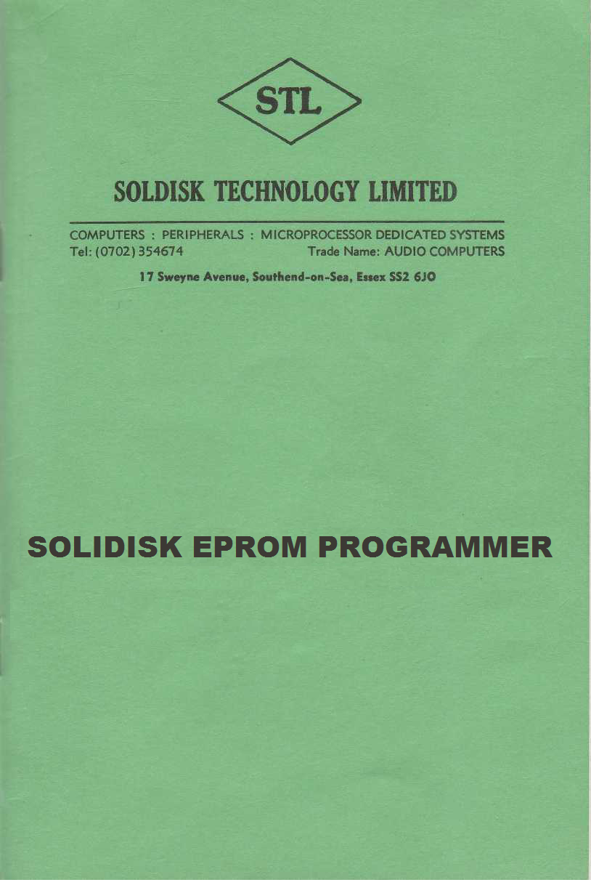

UVIPROM 1.0 – 2.21 AND SOLIDISK EPROM PROGRAMMER

DISCLAIMER:

IMPORTANT:

The Eprom Programmer is a simple device yet requiring great care and attention in handling. In our experience mishandling happens with most eprom programmer users sooner or later. We hereby give notice that no claim whatsoever for any loss or consequential damage to any software or equipment, including the eprom programmer, will be entertained. Under all circumstances our responsibility will be restricted to the servicing, at your cost, any damage caused to the eprom programmer. Eproms as supplied by us or other reputable distributors are certified by the manufacturers. They are not guaranteed otherwise than leaving our premises with the usual caution for handling MOS devices. We do not accept any return for replacement. The present notice is explicitly included in the conditions of sale of the eproms and eprom programmer.

1 THE UVIPROM PROGRAM

The UVIPROM program is specially adapted to drive Solidisk eprom programmer (available as optional extra). It provides between four and seven commands depending on your version:

*READ <filename>
*BLOW <filename>
*COMP <filename>
*VIEW <filename>
*TEST
*UPPER
*LOWER

The system is disk based although it would run from tape. The Uviprom program is Sideways ROM type software.

2 EPROM AND EPROM PROGRAMMER

EPROM (Erasable Programmable Read Only Memory) is the type of ICs that you install into your Sideways ROM sockets. Its appearance is quite easy to recognise: it has a glass window. The EPROMs are normally blank when you buy them from an
electronic computer distributor (such as Watford Electronics, Technomatics or Semicomponents, to cite a few). The BBC computer can only read the EPROMS if they are inserted into the Sideways ROM sockets but cannot write into them as into
Sideways RAM. To do so you will need a special hardware device capable of generating:

1) the correct programming voltage (21-22V);
2) the correct programming pulse (5oms per byte);

This is done by the Solidisk Eprom Programmer.

3 CONNECTING THE EPROM PROGRAMMER TO THE USER PORT

Switch off the computer and turn it over to expose the row of sockets under the keyboard. Connect the 20-pin IDC cable to the user port, situated between the printer port and the 'MHz port. Make sure that the 'bump' on the IDC it mating correctly with the user port socket. Notice a 28-pin socket on the EPROM PROGRAMMER just above the ribbon cable; this is the Programming Socket. Power on the computer. There are two LEDs (Electro-Luminescent Diodes), coloured red, on the EPROM PROGRAMMER. The one nearest to the ribbon cable is labelled `5' (for 5 volts)—the `Vcc' indicator; the other one is labelled `2I' (for 21 volts)—the `Vpp' indicator. Vcc is also the 5v. supply to the Eprom Programmer, borrowed from the user port. Vpp is the programming voltage supply generated by a switched mode power supply built into the programmer.

IMPORTANT:

NO INSERTION OR REMOVAL IS ALLOWED WHEN EITHER LED IS ON.

Permanent damage (pure loss) will result from careless handling of eprom devices. Next to the LEDs are two switches, one for Vcc next to the Vcc indicator, the other is for the Vpp. If you are using the eprom Programmer for the first time try these switches until you are sure to understand how they work: if the switch is on, the LED will be lit; if the switch is off, the LED will go off. Try them as many times as necessary. Notice the small hissing sound when Vpp is switched on: it is generated by the high frequency going through the coil. The Vcc switch does not produce any sound.

Note: By experience we know that mishandling- will sooner or later happen to most Eprom Programmer users, so please pay attention to this device - simple but capable of costing you money unnecessarily.

SWITCH OFF BOTH SWITCHES

4 READ AN EPROM ALREADY PROGRAMMED INTO THE COMPUTER

Before you `blow' the first eprom with the eprom programmer, it is useful to start by reading an eprom already programmed and store it on to your disk. Connect the eprom programmer as per section 3.

5 INSTALL AN EPROM INTO THE PROGRAMMING SOCKET

Place an eprom that is already programmed into the programming socket. Ensure that pin 1 (top left-hand corner) of the eprom is facing the '1' sticker on the eprom programmer. If in doubt ring us for advice. The top of the eprom has a small notch. It should match the same notch on the programming socket. The bottom of the eprom is facing the ribbon cable.

6 RUNNING THE UVIPROM PROGRAM:

Enter: *UVIPROM <RETURN>

The screen should be cleared and you now see:

BBC computer
UVIPROM X.X
Acorn DFS
BASIC

Enter: *READ DUMMY <RETURN>

Dummy is one of the names that you can give to the Eprom being read. You should see: > >Press the BEAK key if Vcc is off< < Press the BREAK key, switch on Vcc (the one nearest to theribbon cable). PRESS THE BREAK KEY AGAIN

Now re-enter: *READ DUMMY <RETURN>

The previous exercise was devised to get you noticing the way the UVIPROM program reminds you to switch on Vcc and how to react to this request. As Vcc is switched on, UVIPROM will start reading the eprom right away. Your disk should be whirring for a couple of seconds and then stops. You may enter:

*DUMP DUMMY <RETURN>

You should recognise the eprom that has been read by reading the copyright notice at the beginning of the DUMMY file. UVIPROM will report disk error if there is any, as usual. Especially, if no valid filename is given it will report:

BAD COMMAND

7 TESTING A BLANK EPROM:

There is no need to switch off the computer. Switch off Vcc. With a small screwdriver, remove the eprom that was read. Place a blank eprom into the programming socket. Switch on Vcc.

Enter: *TEST <RETURN>

You should see: OK

If the blank test fails, the locations where it fails will be displayed. Press the <ESCAPE> key to end the blank test.

8 PROGRAMMING AN EPROM:

Suppose that you have done the blank test to the eprom in the programming socket. Now you are ready to put program your first eprom. Suppose the program you want to put on to the eprom is called 'FOREVER'.

Enter: *BLOW F0REVER <RETURN>

You should hear the disk drive whirring for a couple of seconds, then the prompt: FILE LENGTH & ..................... Program this eprom (Y/N)?: appears. As the eprom programmer cannot distinguish between a 2764 and a 27128 eprom, although it can program both devices, it cannot take a decision; it asks you to take it. Basically the answer is very simple: if the file length is &2000 or less you can put it on to either a 2764-35 or 27128-35 eprom. If it is greater than &2000 but smaller or equal to &4000, a 27128~35 will be required.

Important:

Many programs saved with the MENU programs may show 4000 Hex as file length whereas their true length is only 2000 Hex or less. Please correct this by *LOADing it at 2000 and *SAVEing it again before blowing the eprom.

Example:

You have successfully created an NEWROM in Sideways RAM and saved it with the MENU program.

*INFO NEWROM <RETURN>

NEWROM 8000 D9CD 4000 120

Now enter: *LOAD NEWROM 2000 <RETURN>

*SAVE NEWROM 2000 +2000 D9CD 8000<RETURN>

So if the EPROM is a suitable type, press Y The screen will be cleared and the prompt:

>SWITCH ON VPP AND PRESS <RETURN> <

Do as it says. Both LEDs must be lit before you press the <RETURN> key. The programming sequence is now initiated. To keep your attention a hex dump of data being programmed on to the eprom is displayed. You can halt the programming sequence by holding down both the <CONTROL> and the <SHIFT> keys.
Programming can be abandoned at any time by pressing the <ESCAPE> key. When the programming is terminated, a 'beep' will be sounded and you are asked to switch off Vpp. SWITCH OFF Vpp. Then press the RETURN key.

9 COMPARE AN EPROM WITH THE MASTER:

To ensure that the programming of your eprom is quite successful you can either remove it and use it in one of the Sideways ROM sockets or compare it first against the source file.

Enter: *COMP FOREVER <RETURN>

All the display should be in green. Any mismatch found will be displayed in red. A summary of all mismatches will be displayed at the end of the comparison sequence.

10 THE VIEW COMMAND:

*VIEW <filename> is a colourful version of *DUMP <filename>. It is provided to examine data programs before you program your eprom.

11 THE UPPER COMMAND:

*UPPER will switch to the upper bank of the eprom. This would be used on 16/32K eprom to allow the programming on the upper memory bank.

12 THE LOWER COMMAND:

*LOWER will switch to the lower bank of the eprom. This would be used on 16/32K eprom to allow the programming on the lower memory bank. The lower memory back is selected as default when using UVIPROM.

13 COMMAND SHORTFORM:

Once you get used to the UVIPROM program, commands may be entered in short form with a ' . ' such as *BL., *V.,*COM., *RE., etc. *H. U <RETURN> will show a summary of available commands.

14 UVIPROM SOURCE CODE:

The program 'UVP' is a source code for the UVIPROM. It is included for possible modification for yourself.

