PROJECT

A DRAGON IN THE TUBE
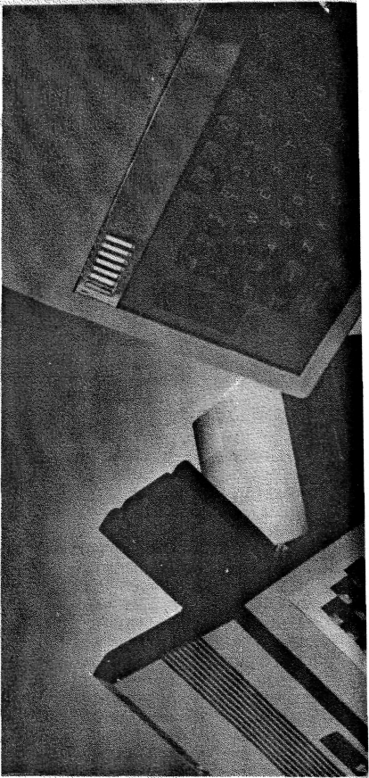

Yes, a Dragon can be used as a 6809 second processor for the BBC micro. Hew Jones' simple interface opens up wider applications, a better operating system, and more memory to the BBC user.
The BBC micro, while undoubtedly a very powerful computer, has a number of serious drawbacks. Apart from the obvious problems caused by the chronic shortage of memory when using the high resolution screens, Acorn's DFS does not bear close scrutiny when compared to systems running a proprietary DOS such as CP/M. [CP/M is an operating system. DFS is a filing system. DFS is much more useful and flexible than CP/M. CP/M should be compared to the BBC MOS, not to DFS.] Such operating systems can boast a wealth of development software such as high level languages and cross assemblers. [The BBC has a wealth of development spftware and cross assemblers. Have you not even bothered looking?] Utilities written for the BBC micro often try their best to 'make do' but rarely succeed in overcoming the lack of available memory (BCPL is a case in point). Having highlighted the failings of the beeb, what are the positive aspects of the computer's design? Unquestionably, it is a superb example of digital design. The operating system software is excellent too, but there is rather a lot of it - 32K of ROM just to run BASIC is a bit excessive [It’s not there ‘just’ to run BASIC. It’s there to run whatever you want to run. Half the OS is VDU drivers, half is a tape filing system. What should we throw away?]. A
major bonus is that ail of the interfaces found ;as optional extras on many home computers are fitted as standard on the beeb, or can simply be installed by adding a few components to the computer's main PCB. These interfaces include the floppy disk interface controller, printer port, RS423 port, A to D converters and no less than three system expansion ports: the 1MHz bus, the user port and the TUBE. This list excludes the obvious attractions of an 80 x 24 text display which is available from any of three video outputs.
A second processor complements the BBC micro by taking over all the computation heavy workload leaving the BBC to concentrate on implementing the I/O. While there are many commercial second processors available, including: Acorn's own 6502 and Z80 designs, this project makes use of a Dragon computer to offer a 6809 second processor system.
Enough has been said in praise of the 6809 MPU and it is a matter of regret that the Dragon never achieved the commercial success that it deserved. The designers of the computer did themselves no favours by restricting the display to a 32 x 16 upper case text only but they did build in 64K of RAM and a bus expansion facility. This is exactly the specification expected of a 6809 second processor.
Accepting that we are to use a Dragon computer as a second processor, what do we do with it? A simple approach would be to use the BBC micro as an extension of the Dragon's I/O capability. This could be accomplished by attaching appropriate software onto the Microsoft BASIC 'hooks', most existing Dragon software couid be made to operate in a smart 80 column mode with disks. Most people would however, not unreasonably, expect a 6809 second processor to run a 6809 operating system — either OS9 or FLEX.
The former is an excellent package supporting multi-tasking (great!) and multi-users (impractical in a floppy disk based system). Unfortunately, with the exception of Dragon Data's version, OS9 is very expensive. Conversely, FLEX has a broader market and is generally lower in cost with much more software in existence. It is well documented, available in a wide variety of standard disk formats, simple to use and convenient for development work. Both operating systems are capable of being customised for new hardware configurations, the FLEX Programmer's Manual being very helpful in this respect. All things considered, it nadto be FLEX. A final nail in the coffin of OS9 is the fact that the Dragon version is supplied on double density disks which cannot be read by the 8271 FDC in the beeb.
For those who possess a BBC model B with Acorn's DPS and dual disk drives then adding this second processor will not incur much expense apart from the purchase of the FLEX licence, ie a copy of the DOS. Ignoring the low component cost of the TUBE interface itself, the Only other item required is the Dragon computer, A Dragon 64 is ideal but a Dragon 32 can be used providing that it is fitted with 64K of addressable RAM. '" :•
THE FLEX OS
The FLEX operating system originated in the United States. Written by TSC, FLEX is a powerful OS designed make the best use of the features of the 6809 MPU.
A wide range of applications packages is available for FLEX systems. These range from software development aids to a full suit of general and business software. Such packages include a variety of word processors; Dynacalc, apowerfulspread-sheet system; the RMS data management system; and specialised business software such as cash and VAT and purchase ledger packages.
10 – ELECTRONICS & COMPUTING MONTHLY AUGUST 1985
Compusense offers full support for FLEX in the UK and via its contacts in the USA has access to a vast number of applications packages. Compusense, PQ Box 169, 286D Green Lanes, Palmers Green LONDON, N13 5XA,

How it works
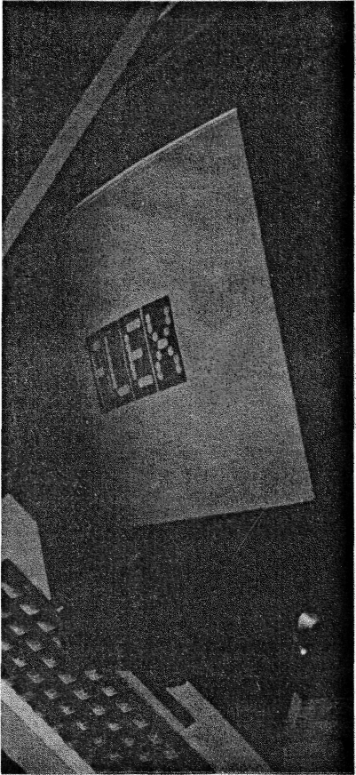
 | •-••'-'• " ' ' '•.'> •'•'. • '.'.-. I
(PC6)  i | L_ 6809 READS DATA i FROM TUBE  ' !.-: 1  L '
(PC4! • i 6809  lt^tot  i  i STATUS XFOReSf | WRITES DATA JBE I  j. • •.--.. ' SET ! j 1 )2 RESET BY 6502 j
IBF j  mpci ^ ^ | * REGISTER i 1  t . - • ...
I i | * ""!  I GOESLOWWHEN I j ; 6502 WRITES TO PORT A
DBF I j (PC7! j j  - 1- - f  'ntra! ^__ | ; L^. RESET WHEN 6809 i 1 I ACCFPTS DATA i
DBF I j (PC7! j j  - 1- - f  'ntra! ^__ | ¹ 1 ACTIVE WHEN 6502 1
(IN) j (PCS) |
1  1  INTRAl (OUT) , | 1 1 t ACTIVE WHILST AN !
1  1  INTRAl (OUT) , | (
(K-jt r — '  1  ! _{t} SEQUENCE | j ;•• • j.._  OF EVENTS SEQUENCE OF EVENTS
6809 T  Figure 2. TUBE data trans | D 6502 6502 TO 6809  fer.
Despite all the mysterious references to the TUBE in the BBC User Guide, it is merely an extension of the, CPU bus, brought 'raw' to the 40 way IDC TUBE plug. A TUBE select signal is provided which becomes active in the range SFEEQ-$FEFF. External hardware is required before the TUBE can do anything at all and even then any data transfer must rely heavily on software; Acorn's answer was to produce a custom ULA to interface the micro to its co-processor whilst other designs have used the simple expedient of using two back'-tq-back VIAs. This design goes one better and implements a 2MHE TUBE interface with just a single 8255 PPI and a few support TTL chips,
The complete circuit diagram of the TUBE: interface is shown in Figure 1. Connector CONN 1 is a 40 way IDC header which; mates with one end of a 40 way ribbon cable terminated at both ends by 40 way IDC sockets. The other end plugs into the TUBE connector of the BBC micro. Keep the cable short, say 2ft maximum. CONN 2 is a 0.1" pitch double side edge connector which plugs into the Dragon cartridge port,
IC4 is an LS245 bi-directional buffer which isolates the 8255 from the 6502 data
bus until the TUBE select goes low (SHEILA, offset EQ-FF). Similarly IC5, an 81LS95, buffers the 6502 control signals. The outputs from this chip, and hence IC4, are only enabled when both the BBC and the Dragon are powered up. If the Dragon is on but the BBC off then IC5 and IC4 have no supply rail whilst if conditions are reversed, Q2 will be off and its collector will pull pin 19 of IC5 high. In this tri-state condition, IC4 is also disabled due to R2 pulling pin 19 high.
The correct power-up sequence is to first switch on the BBC micro, followed by the Dragon when the beeb has made its customary 'ready* tone. As part of the BBC computer's initialisation procedures, the computer's MOS polls for the presence of a second processor and will perform a TUBE set-up routine if it decides that there is one. This assumes Acorn's own ULA to be fitted. In the absence of formal documentation [so, the Advanced User Guide, the New Advanced User Guide, the BBC OS Reference Guyide, Inside the BBC MOS and others don't count as documentation?] and the lack of inclination to disassemble the BBC ROM [you can’t even be bothered to disassembled 800 bytes of code?], it has been presumed that the BBC micro acknowledges the presence of a second processor if, and only if, it reads a $FF at $FEEO immediately after a hard reset. Until its mode of operation is configured by the BBC, the 8255 will be in its default, high-impedance input state for ports A, B and C. Thus random sampling of the TUBE (port A) by the BBC will return the instantaneous value of the 6809 data bus which could be anything. If the TUBE check is made before the Dragon is switched on however, the 6502 is forced to read all zeroes due to the pull-down action of RPK1.
The Intel 8255 is a popular peripheral, often used in straightforward control appli-
The cheapest Way to obtain a Dragon computer is via the 'For Sale* columns of specialist computer magazines. Prices for the machines can vary greatfy but it should be possible to buy a second hand Dragon 64 for under £100. Remember though, it is necessary to use a 64K computer in the second processor project. There are many 32K machines Offered for sale but these will not be suitable unless fitted with an extra 32K of RAM (an article describing this conversion is scheduled for a future issue of Electronics and Computing).
The alternative is to buy a new machine via Compusense, the UK distributor of Dragon products. The company can be reached on 01 882 0681. The price of a 64 is £195 inclusive of VAT.
cations. It has two 8 bit ports, A and B, and two nibble wide ports, C lower and C upper. These can be configured on a group ;-asis, as either input or output. This operation only involves writing to the appropriate registers within the 8255. This method of I/ 0 is known as mode 0. Mode 1 offers the facility for operating port A in either input or output with handshaking functions built-in to three lines of port C. An extension of this principle is mode 2 whereby port A is suitable for bi-directional data transfer with five lines of port C used for the handshake protocols. This indeed is the mode used here, set up by the BBC writing $E2 to the 8255 control register.
Aliming diagram for a typical data transfer is shown in Figure 2. Assume that the 6809 wishes to output a character to the

AUGUST 1985
ELECTRONICS & COMPUTING MONTHLY-

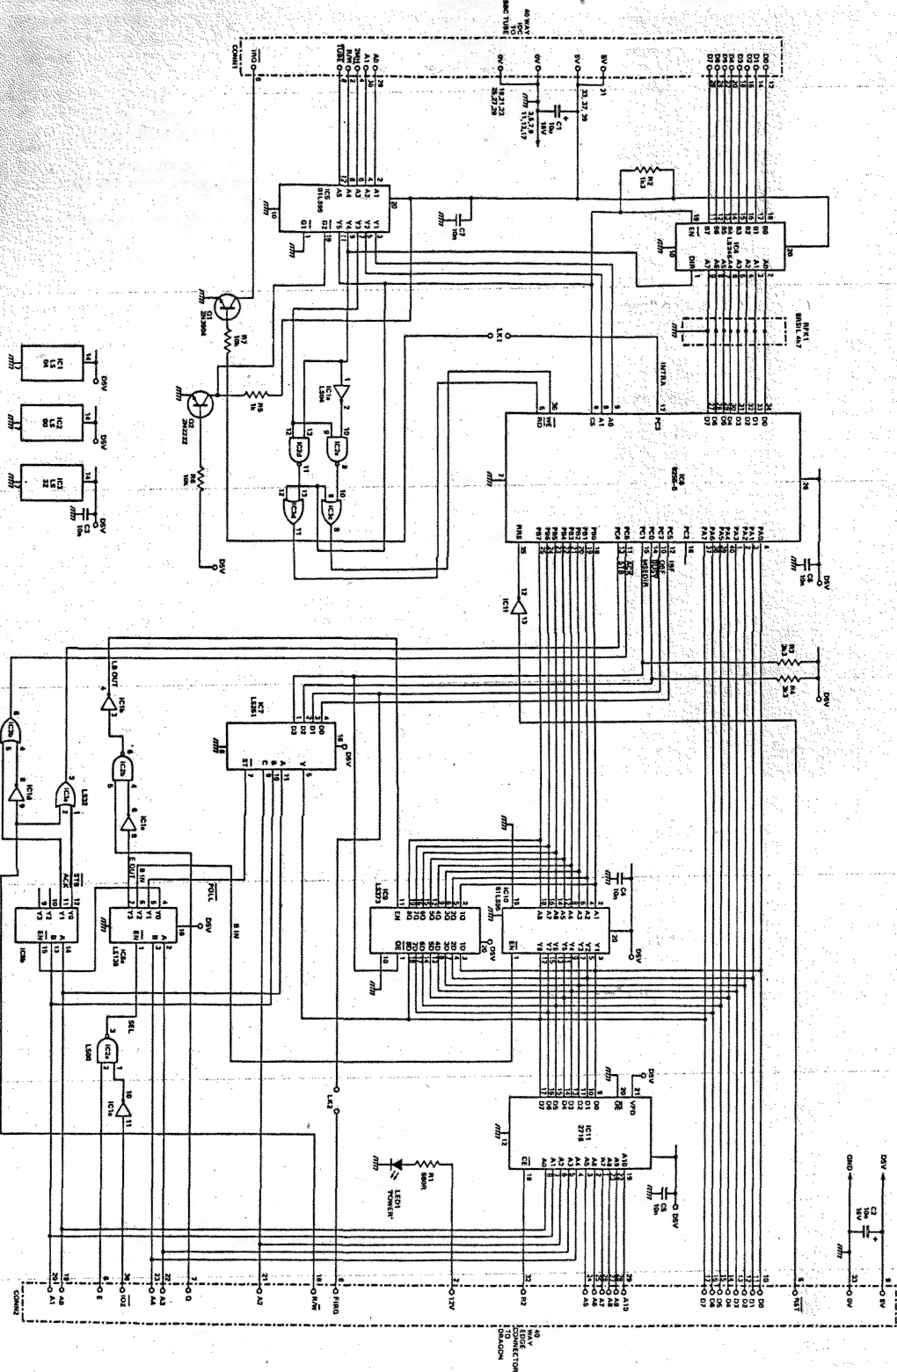
Figure 1.

. ELECTRONICS* COMPUTING MONTH, Y^__
AUGUST 1985

PROJECT

BBC micro through the TUBE. It first writes the ASCII code to SFF40 which is decoded via IC8b, half an LS139, which produces a low pulse on the STB (PG4) input of the 8255 just as the data appears on the data bus at port A. This effectively latches the data into the 8255 and sets IBF (PCS) bit in the 8255 internal port C status register which signifies an input byte is ready. The 6502 detects this by polling SFEE2. An output, IBF, mirrors the status of this bit to the 6809, which tests its state by reading from SFF48. An LS251 data selector, IC7, passes IBF to D7 of the Dragon data bus. When the BBC acknowledges the character by reading the port A register, IBF automatically returns to the idle state (low) and the TUBE is available for further transfers. Overrun is prevented by the 6809 software which must always check IBF before releasing a character to the BBC.
For transfers in the opposite direction, the 6502 writes a data byte to the 8255 port A register ($FEEO) which is loaded into the 8255 output buffer and sets OBF (PC7) low to indicate to the 6809 that a character is pending. Again, the 6502 can monitor the current state of this output through the 8255 port C register. The Dragon reads the status of OBF from SFF49, recognising that a byte is waiting if it returns a positive value (below $80). It fetches the byte by reading from $FF41 which puts a low strobe pulse on ACK (PC6) to enable the 8255 output buffer which places the byte onto the second processor data bus via port A. INTRA (PCS) is an interrupt output from the
8255, linked to the 6502 IRC; line by Q1, an open-collector inverter. An interrupt could be made to occur on receipt of an incoming byte or when a character output sequence has completed.
With this scheme, port B and three lines of port C are redundant which suggests an auxiliary data transfer channel could be implemented. In fact a message port has been incorporated within the design, the
NEXT MONTH
TUBE software and how to
customise FLEX to operate across
the TUBE and details of how to
obtain the pcb and kit of parts.
only cost penalty being two LS chips. Transfer of data through port B can occur in either direction but the 6502 must always configure the mode of port B prior to the change of data direction. An output is assigned, MSDIR (PC1), which informs the 6809 whether port B is currently available for read ($FF58) or write ($FF50) and controls the OE, pin 1, of IC9, an LS373 latch used for data from the 6809 to the BBC. No conflict thus occurs with IC10, another 81LS95, which buffers port B data in the opposite direction until enabled via pin 1. A pull-up resistor, R3, ensures the LS373 is disabled whilst the 8255 is in its
post-reset state. MSGDIR is tested by the 6809 through polling SFF4B. Another port C (PCO) is designated a 6502BUSY output, sampled on the second processor side by reading SFF4A- if positive then the 6502 is free. Note that it is the 6502 software which controls this signal. At the moment, MSGDIR and 6502BUSY are used to:-
- pass command completion
semaphores from the 6502 to the
6809.
- synchronise the second processor
to the host when it is engaged in pro
cessing a time consuming command
such as reading from a disk.
the combinational logic, comprising gates 1 a, 2c, 2d, 3a and 3d, convert the 6502 bus control signals into versions suitable for the 8255. It is important that a 5MHz part is used for the latter device in order to run at the 2MHz rate of the TUBE.
Link options are provided so that incoming data bytes could be serviced by interrupts on both CPUs. These are currently left open-circuit since interrupt driven transfers offer no substantial benefits and present some awkward problems on the 6502 side. A 2716, IC11, is used to hold the 6809 FLEX BOOT software which is copied across to RAM at $F800 in map type 1. The circuit around, and including IC8, generates the various signals needed to route any data and ensures certain addresses are read-only or write-only as appropriate. A 'power-on' LED is included for completeness.

Electronics and Computing
SPECIAL OFFER

The Experimenter ROM
By Mike Williams Summary of commands:
ALARM DIAGRAM OSCOMS PULSE
BARS FNKEYS OUT ROMTABLE
BINARY IN PIN VOLTS
BYTE LEDS PORT SCOPE
Regular readers of t&CM will recognise the name of Mike Williams - we have published a number of utilities written fay him in past issues.
We have now collected all the published routines together and added a number of new utilities to produce the 'Experimenter' ROM.
The brief description of the available commands will show just how versatile the 'Experimenter' is. The 'Experimented should be of great interest to those working in education. The graphic representation of physical quantities makes the presentation of
many science experiments synamic and thus easier lor the student to comprehend.
SCOPE
produces a scrolling oscilloscope - like display of the analogue voltages with facilities for variable scroll speed and for freezing the trace.
At present the 'Experimenter' It not available in the shops. To order at the Special Price of £17.50 plus 50p p&p please send a cheque or postal order to MEWsoft, 11 Cressy Road, LONDON NW3 2NB
STOP PRESS
Experimenter will be available from the l&CM stand at the Acorn User Show, where the 'Experimenter' will be offered at a special price of £16.00 - and of course there will be no postage to pay.

ONL Y£17.50 plus 50p p&p
Supplied by The British Library - "The world's knowledge"

